DEVELOPMENT REVIEW COMMITTEE
4601 State Avenue, Suite 88
Kansas City, Kansas 66102
(913) 573-8664 phone
(913) 573-8622 fax
edr@wycokck.org

HOME PAGE

The Development Review Committee (DRC) is comprised of a representative of each reviewing department; Building Inspections, Planning, Engineering, Public Works, B.P.U. Water and Electric, Fire Prevention, and the Health Department. The committee reviews new commercial development, additions, occupancy changes, commercial pools, and exterior renovations.

Unified Government has adopted the following codes and ordinances:

- 2012 International Building Code
- 2012 International Mechanical Code
- 2012 Uniform Plumbing Code
- 2011 National Electrical Code
- 2012 ASMES Elevator Code
- 2009 International Fire Code
- Current NFPA Life Safety Code
- Ordinances of the United Government of Wyandotte County / Kansas City, Kansas

DRC PROCESS

- Pre-application meetings are available with DRC. The purpose of the pre-application meetings is to provide applicants with the opportunity to meet with City representatives, identify potential issues, assist the applicant in preparing their submittal to the City, and to expedite processing of the development application. Pre-application meetings are advisory only. To schedule a meeting or for additional information, please contact Kim Portillo, DRC Coordinator, at (913) 573-8664.

Prior to scheduling a pre-application meeting with DRC, we recommend you contact Urban Planning and Land Use to discuss your project. Depending on your scope of work, zoning, and use you may need file an application for the Planning Commission. If this applies to your project, approval from the Planning Commission is required before any building permits can be issued.

- Submittal Requirements: Eight (8) sets of complete plans, two (2) spec books, building permit application, and the plan review fee are required at the time of submittal. All plans and specification are required to be prepared, designed, signed and sealed by an engineer or architect licensed by the State of Kansas. Projects are distributed to DRC on Tuesdays and Thursdays. .

Projects with commercial pools and pre-package food are required to be reviewed by the UG Health Department. Projects involving food service establishments, taverns, private clubs, nursing homes, child care, schools, or hospitals are required to be reviewed by the State of Kansas Department of Agriculture. The applicant is responsible for providing the required plans to these departments.

- Plan Review- Plan review comments are anticipated within the first 5-10 business days of new and resubmittals. Plans are reviewed in the order received. Departmental Requirement and Recommendation forms (plan review comments) will be emailed or faxed to the project’s point of contact. One digital and one hard copy of plans are to be resubmitted if revisions are required. As of May 1, 2008, resubmittals (3rd plan review) with a significant change in design and projects with multiple plan reviews may be subjected to additional plan review fees. Single sheet revisions are not longer accepted and shall be included and resubmitted in a complete set.

- Issuance of the Building Permit– Site Grading and Footing and Foundation permits may be requested (prior to the full building permit) but are subjected to the review and approval of DRC. An additional fee of $200 is required with the issuance of a Footing and Foundation permit and the project is required to comply with inspections. If the project is over an acre and erosion control is required a Land Disturbance permit must be acquired with the Public Works Department before any site work may begin.

- Approval from all reviewing departments is required for a building permit to be issued. At the time of issuance, the Department Requirement and Recommendation forms are required to be signed and returned, and the building permit fee paid. Additional permits and fees may be required by other reviewing departments.

- Inspections- Upon completion of the project, DRC members will conduct final inspections prior to the issuance of a certification of occupancy. This final inspection is to assure that all the requirements have been met and all ordinances have been complied with.

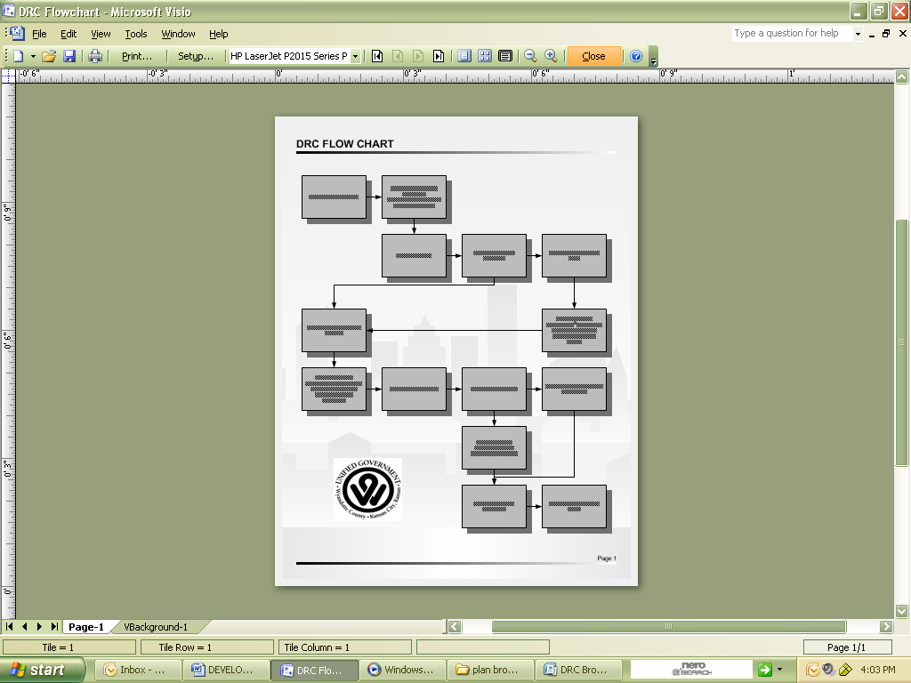

DRC APPLICATIONS AND FEE SCHEDULE

Fee Schedule
  - Plan Review
  - Building Permit
  - Trade Permit
  - Sprinkler Permit

DRC Applications
- Building Permit
  - Demolition
  - Trade Permit

ADDITIONAL CITY APPLICATIONS FOR DEVELOPMENT

Urban Planning and Land Use Department
  - Development Application
    - Change of Zone
    - Special Use Permit
    - Vacation
    - Subdivision Plats
    - Plan Review
    - Revised Plans
    - Master Plan Amendments
    - Non-Conforming Use
    - Board of Zoning Appeals Variance
    - Landmarks
    - Certificates of Appropriateness
  - Sign permit application

Public Works Department
  - Land Disturbance Permit Application (allows contractors to establish erosion control measure and site grubbing only)
  - Hauling Permit Application

Fire Prevention
- Fire Sprinkler Permit Application

CONTACT US

Kimberly Portillo, DRC Coordinator | (913) 573-8664 | kportillo@wycokck.org
Anthony Hutchingson, Chairman, Building Inspections | (913) 573-8630 | ahutchingson@wycokck.org
Byron Toy, Planning and Zoning | (913) 573-5757 | btoy@wycokck.org
Harvey Fields, Fire Prevention | (913) 573-5550 | hfields@wycokck.org
Brent Thompson, Public Works – Engineering Division | (9130)573-5736 | bdimaggio@wycokck.org
Kimberly Ingham, Planning and Zoning – Engineering Division | (913) 573-5723 | kingham@wycokck.org
Kelly bobki-Lindblad, Board of Public Utilities | (913) 573-9846 | Kbobki-lindblad@bpu.com
Jenny Li, Board of Public Utilities – Water | (913) 573-9845 | jli@bpu.com
Courtney Connor, Board of Public Utilities | (913) 573-9838 | cconnor@bpu.com
Rollin Sachs, Health Department | (913) 321-4803 | rsachs@wycokck.org

ADDITONAL CONTACT INFORMATION

UG Health Department | (913) 321-4803 p.
619 Ann Ave., Kansas City, Kansas 66101
Kansas Department of Agriculture | (785) 296-5600 p. | (913) 785-296-0673 f.
109 SW 9th Street, 3rd Floor, Topeka, Kansas 66612

PLAN REVIEW CHECK LIST

GENERAL SITE PLAN REQUIREMENTS
- Project name and address
- Legal description of the development site and vicinity map
- Building use, type, and/or purpose
- North arrow & scale 1”=20’ or 1/16” minimum
- All property lines, all existing and proposed utility and utility easement(s), project benchmark, and right of way
- Location with regard to street (lot and block or tract)
- Proposed and/or existing setbacks
- Proposed and/or existing curb cuts
- Proposed and/or existing drives and walks (indicate type of material)
- Proposed and/or existing grades
- Proposed and/or existing off street parking including compliance with ADA
- Proposed and/or existing landscaping (specific type, size and location)
- Proposed and/or existing trash container, bin or dumpster location and screening information
- Flood zone information when applicable
- Structure(s) to be demolished
- Location and size of water main serving lot shown
- Existing and proposed sanitary sewers
- Storm sewer inlets and associated piping if applicable
- Elevations -
  - Finish floor
  - Finish curb or crown of street at points of extension of lot lines
  - Locations and existing elevation of sanitary sewer stub to be utilized by the lot shown including UG node number
  - Location of and existing elevations of upstream and downstream manholes including UG node number
  - Existing and finish elevation at each corner lot
  - Elevations of top of foundation to be utilized by the sanitary sewer

BUILDING INSPECTION DIVISION
- Name of developer
- Name, address, and phone number of contact person
- Complete structural plans, including floor layout, building elevations, and electrical, plumbing, and HVAC plan/details
- If any new easements are required the site must be platted (Unified Government of Wyandotte County/Kansas City, Kansas Ordinance No. 51425, Section 42-4(1)
- Code footprint including but not limited to: construction type, occupancy load, egress plan, and area increase data

FIRE PREVENTION
- Fire exits
- Fire escapes
- Sprinkler systems (when applicable)
- Smoke towers (when applicable to high rise structures)
- Stand pipes (when applicable)
- Fire alarm system
- Fire control and detection equipment
- Fire pumps (when applicable)
- Shaft-ways
- Fire walls and stops
- Hose wells
- Smoke detectors

PLANNING AND ZONING DIVISION
- Site plans are a required submittal and must include:
- Floor plans
- Landscape plans
- Building elevations, including materials and color
- Sign elevations, including materials and mechanics
- Projected number of employees and people served by the project

HEALTH DEPARTMENT
- Supply plans and specifications of kitchen/meat room equipment, building materials and the location, size and type such equipment and facilities for:
- Grocery and Convenience Stores
- Nursing homes and child care centers
- Plans and specifications of all private sewage disposal systems
- Plans and specifications of all public swimming pools

Department of Air Quality Requirements
- State and local air pollution regulations require the registration and prior approval of all new or modified sources of air contaminant emissions with the Department of Air Quality (DAQ). The DAQ will supply the necessary application forms, conduct any necessary evaluation and issue appropriate construction permits or approvals. Assistance is available to any source operator in applying for necessary air permits/approvals and in understanding and complying with all local, state and federal air pollution regulations by calling (913) 573-6700.
- Major sources of air emissions must also apply for and receive an operating permit from DAQ.

PUBLIC WORKS-ENGINEERING DIVISION
- Intersection drawings
- Type of waste produced
- Method of sewage disposal
- Are sanitary sewers available? If private sewage systems detailed plans and specifications are required: Unified Government of Wyandotte County/Kansas City, Kansas Ordinance, Article V, Section 32-75-86.
- Projected daily sewage load (gallons)
- Plans and specifications showing location, size, and type (sanitary, process, or storm) of all discharge lines into the municipal sewer system and the service proposed from the street water main to the control valve in the building
- Plans and specifications pertaining to the connection of roof, areaway, garage, or foundation drains, sanitary and process sewer lines into the municipal sewer system. By ordinance no surface water or water from roof and foundation drains may be discharged to a sanitary sewer.
- Meter and meter pit location, meter pit pipe and meter pit details for water not provided by the Board of Public Utilities of Kansas City, Kansas, which is discharged into the municipal sewer system.
- Plans and specifications of all pretreatment systems designed for pollutant removal from wastewater.
- Number of each type of water fixtures to be supplied
- Plans and specifications for surface water runoff including construction phase erosion control.
- Method of electrical power, telephone service, and cable television shall be provided by underground wiring for all new wiring provided as required: Unified Government of Wyandotte County/Kansas City, Kansas Ordinance 27-708. See Ordinance for exceptions.
- The Public Works Department also needs to be supplied with the projected number of employees, the projected number of persons to be served by the project, and the projected growth rate.

PLANNING AND ZONING-ENGINEERING DIVISION
- Requirements and check lists for sanitary sewers, storm drainage, streets, erosion control, and land disturbance are available under the Planning Departments website.

BOARD OF PUBLIC UTILITIES – WATER AND ELECTRICAL DISTRIBUTION DIVISIONS
- Water Main – Is a water main available and adequate to supply the proposed project? If water mains are not available at site, a main extension may be required to be constructed at developer’s expense
- Proposed electrical power including:
- Electrical one-line or riser drawings,
- Proposed panel board schedules, indicating electrical load in kVA, if known.
- Equipment lists calling out other major equipment that will require electrical power, to include electrical load, when known.
- If the project is to be built in phases, one overall or final plan is required. Two sets of plans are required:
- Site plan
- Mechanical plans including:
  - Dedicated public right of way, roads, property lines and easements
  - Number and type of units and water fixtures to be supplied
  - Size, type of pipe and type of service proposed from water main to service control valve in building
  - Proposed location of meter and/or meter pit, meter pit piping detail, meter pit detail
  - Specifications and plans shall include the statement; “the plumber shall comply with the rules and regulations of the Board of Public Utilities.”

UG HEALTH DEPARTMENT AND KANSAS DEPARTMENT OF AGRICULTURE FOOD SAFETY
- Projects with septic systems, commercial pools, and pre-package food are required to be reviewed by the UG Health Department. It is the applicant’s responsibility to provide the UG Health Department with one (1) set of complete plans.
UG Health Department
619 Ann Avenue
Kansas City, Kansas 66101
p. (913) 321-4803

- Food service establishments, taverns, private clubs, nursing homes, child care, schools, or hospitals must submit one (1) set of complete plans to the Kansas Department of Agriculture. Establishment must be inspected and approved before opening.

Kansas Department of Agriculture
109 SW 9th Street, 3rd Floor
Topeka, Kansas 66612
p. (785) 296-5600 f. (785) 296-0673
www.ksda.gov/food _safety

DRC FEE SCHEDULE
There are two fees associated with DRC; plan review and building permit. The plan review fee is based off your total project valuation including all trade work. The building permit fee is calculated off the building cost (minus the trade work). A plan review fee of $228 from the Board of Public Utilities is included in the plan review fee.
Project Valuation | Fee Calculation | Rounds to
$0-$30,000 | $30 base fee + .75 per each $100 value of work | Nearest .75
$30,001-$1,000,000 | $255 base fee + .50 per each $100 value of work | Nearest .50
>$1,000,001 | $5105 base fee + .40 per each $100 value of work | Nearest .40
Board of Public Utilities | $228

Calculation Example for Plan Review and Building Permit fee:

$10,000 project valuation
$10,000/$100 value of work = 100
.75 x 100 = $75 + $30 base fee = $105.00 Totals the cost of the Building Permit

Plan review fee is half the building permit cost, plus $228 BPU fee.
$105/2=$52.50 + $228 BPU fee = $280.50 Plan review fee

